Orientation Program for the First Year Degree Students
The Internal Quality Assurance Cell and the Alumni Association of the College jointly organised an orientation programme for the first-year degree students on 1st, 2nd and 3rd September 2022.
The main focus of the program was to ensure the students aware of the academic aspects of the course, enhance skills, setting goals, understand the new education policy and make the students aware of College environment.

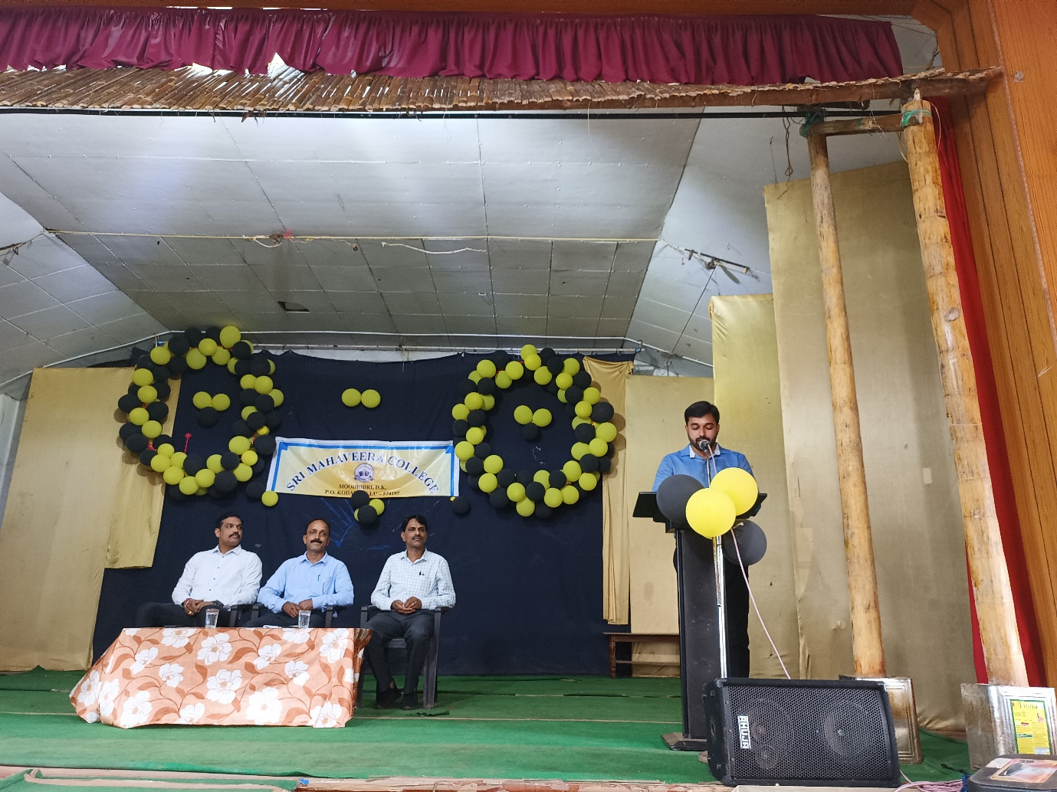

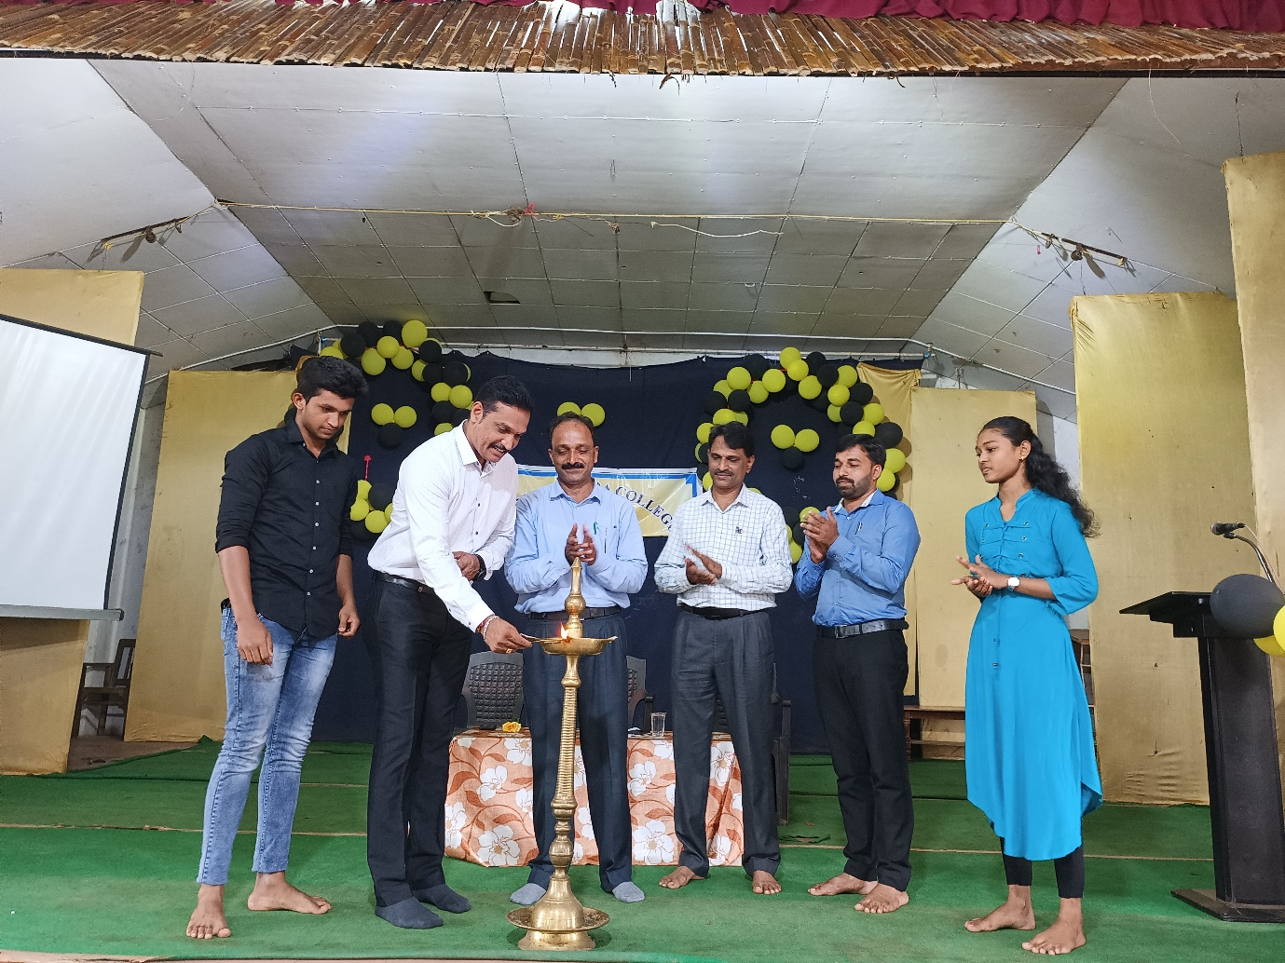

1st September 2022- Inauguration
Inauguration of the three days orientation program was held on Thursday, the 1st September 2022 in the College Auditorium at 9.30 a.m. The program began with an invocation by Mrs.Shruthi S Dange, Lecturer in Commerce. Mrs. Padmashree, Lecturer in Commerce welcomed the gathering. Sri Nagaraj B, President of S.M.C Alumni Association, inaugurated the program by lighting the lamp. In his inaugural speech, he guided the students to achieve their dream by getting good education in this institution. He wished good luck to the students. The program was presided over by Dr. Radhakrishna, Principal, Sri Mahaveera College. Mrs. Shrigowri K, Lecturer in Economics proposed the vote of thanks.
Session 1: 10.30 a.m. to 11.30 a.m.
NSS, NCC, Rangers, Sports and Red Cross Officers explained the activities organised by these Units.
Session 2: 11.30 a.m. to 12.30 p.m.
This session was taken by Dr. Radhakrishna, Principal, Sri Mahaveera College, Moodbidri. He explained the rules and regulations of the College to be followed by the students.

Day 2: 2nd September 2022.
Session 1: Topic : Scholarship for Degree Students (9.30 a.m.– 10.30 a.m.)
Resource person: Mr. Chandrashekar S, Senior Engineer, M.C.F Ltd., Mangalore.
Mr. Chandrashekar S, Senior Engineer, M.C.F Ltd., Mangalore gave information about the various scholarships available to students under various categories. He also mentioned the different Govt. schemes for students and the procedure to be followed to avail the facility. He suggested the students to be aware of crimes in scholarship field.
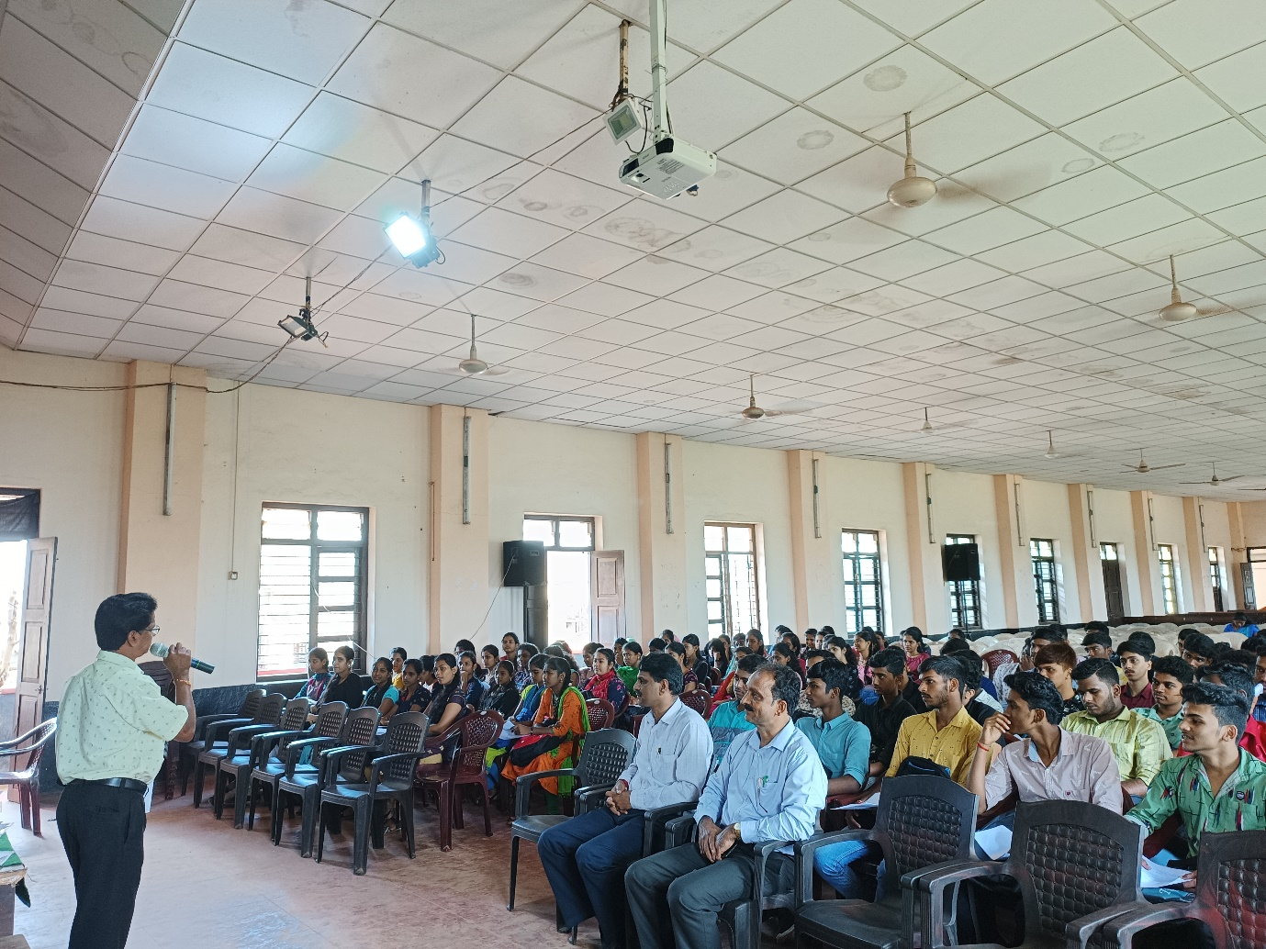

Session -2 : Topic : Values in Education (10.30 a.m. – 11.30 a.m.)
Resource person – Mrs. Sujatha, Lecturer in Sociology
Mrs. Sujatha, Lecturer in Sociology took a session on ‘Values in Education’. She explained different values to be followed by students to become good human beings. She explained values in education by giving living examples. The session was informative.
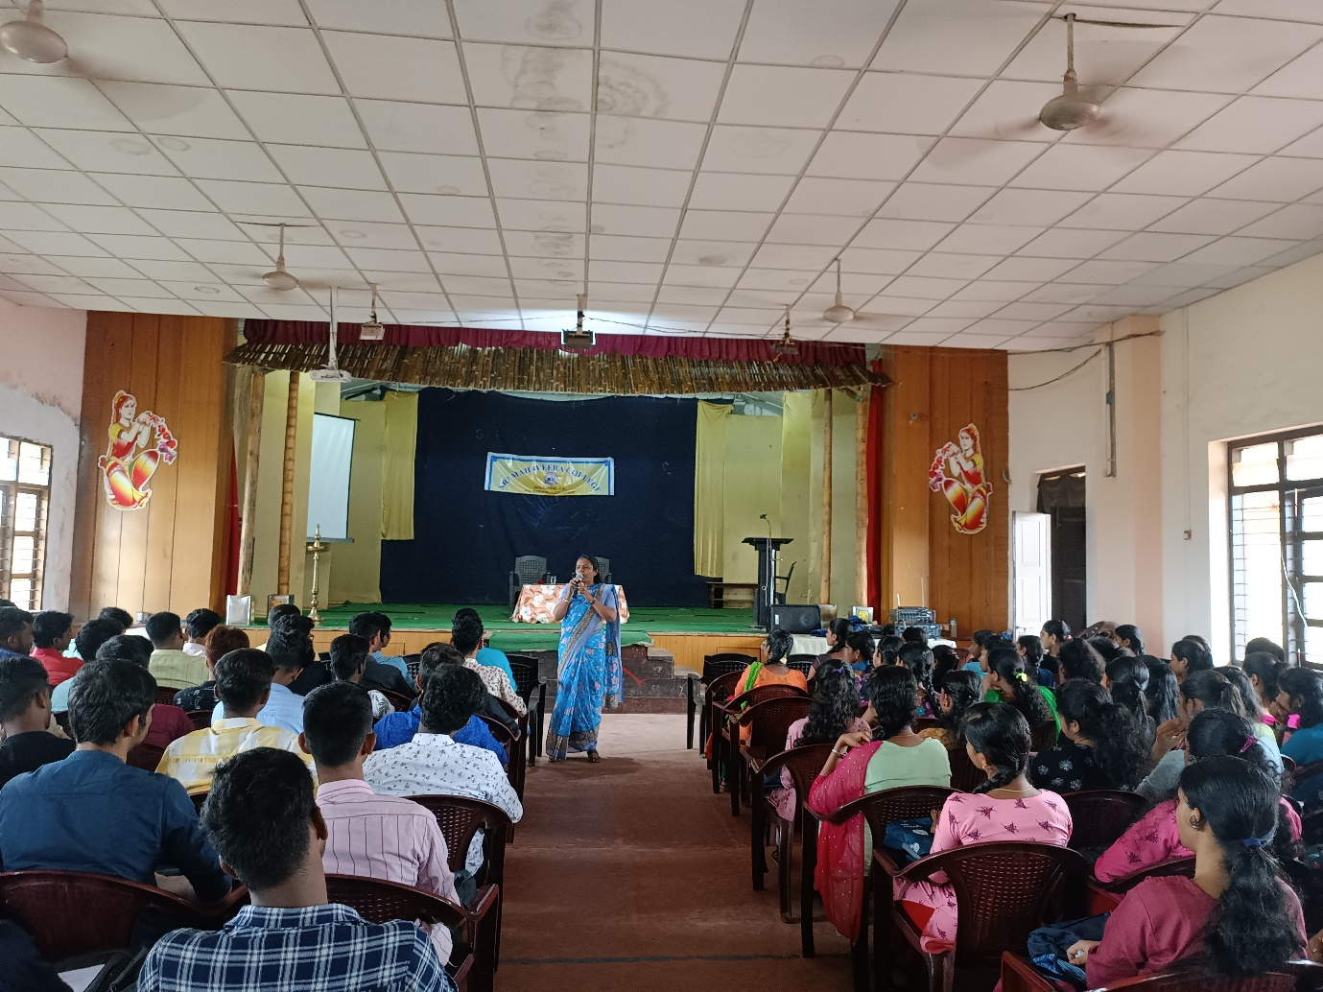

Session 3 : Topic – Etiquettes (11.30 a.m. to 12.30 p.m.)
Resource person – Mr. Nagaraj B., M.D , Novo Tree Minds Consulting Pvt.Ltd.
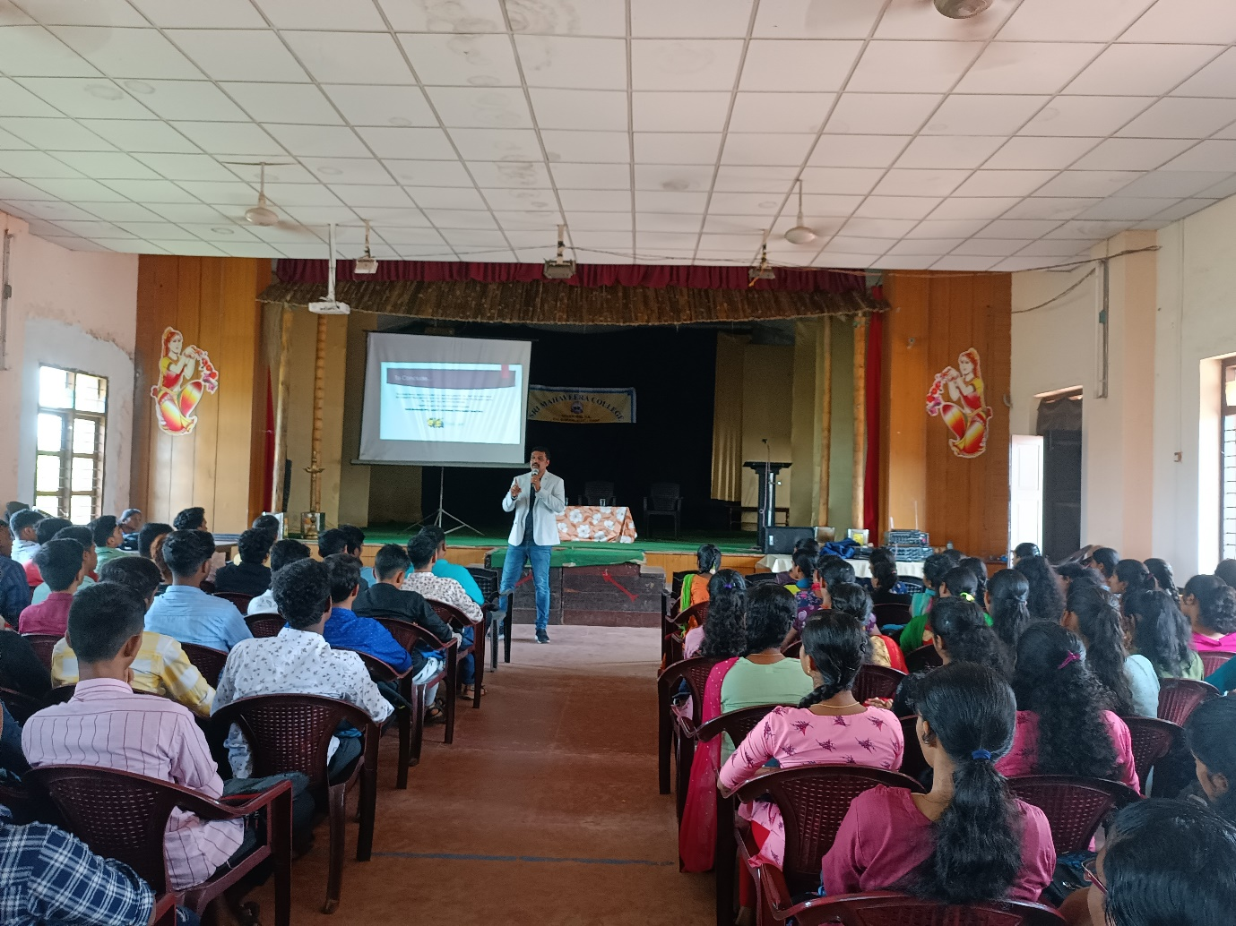
Mr. Nagaraj B, M.D , Novo Tree Minds Consulting Pvt.Ltd. delivered a talk on ‘Etiquettes’. He explained the way of behaviour to be maintained by the students. He also mentioned the good qualities a student must inculcate to achieve success in life. The session was interactive and all the students actively participated.

Day 3- 3rd September 2022
Session 1 - Topic – Goal Setting (9.30 a.m. to 11.30 a.m.)
Resource person – JCI Varsha Kamath
JCI Varsha Kamath delivered a talk on ‘Goal Setting’. She stressed on why the goals are important, how to set proper goals and how to achieve them. She emphasised on positive thinking and also explained how to analyse the dream and achieve goal.

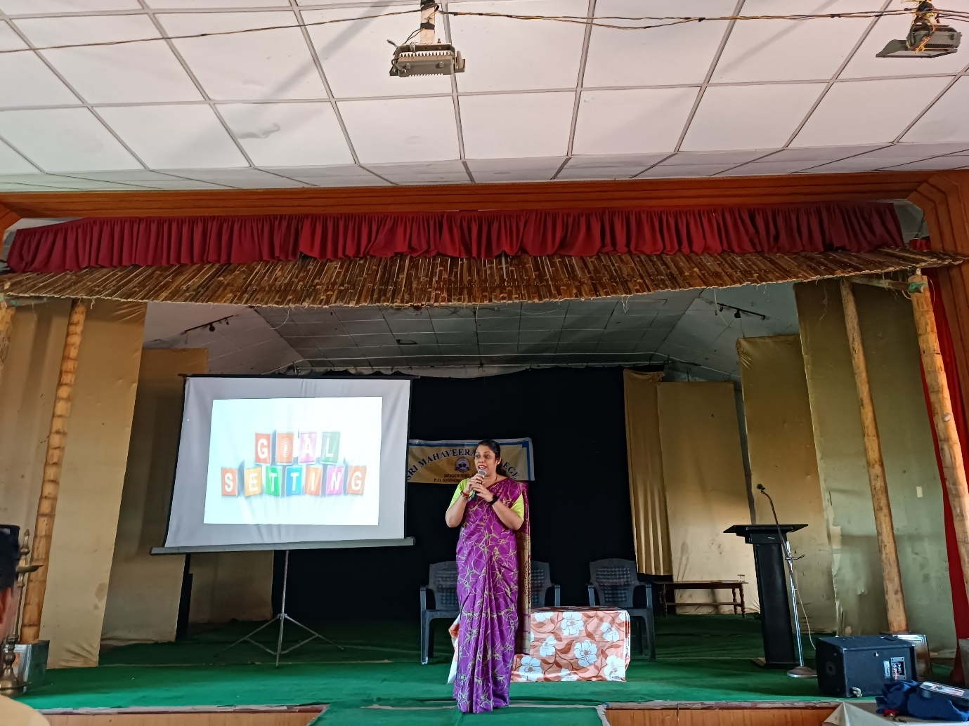

Session 2 – Orientation about the College Library (11.30 -11.50 a.m.)
Mrs. Nalini K , Senior Librarian, Sri Mahaveera College gave information about library usage to the new students.

Session 3 – Topic- ‘How to build self-confidence’ (11.50 a.m. – 12.30 p.m.)
Resource Rerson – Dr.Praveen K, H.O.D of Political Science

Dr.Praveen K, H.O.D of Political Science took a session on the topic ‘How to Build Confidence’. He explained various living examples to make students more confident.
